Strategy Steering Committee

WESTERN CAPE WATER SUPPLY SYSTEM
RECONCILIATION STRATEGY

Progress Report

October 2010

To be read in conjunction with the Status Quo Report - December 2009

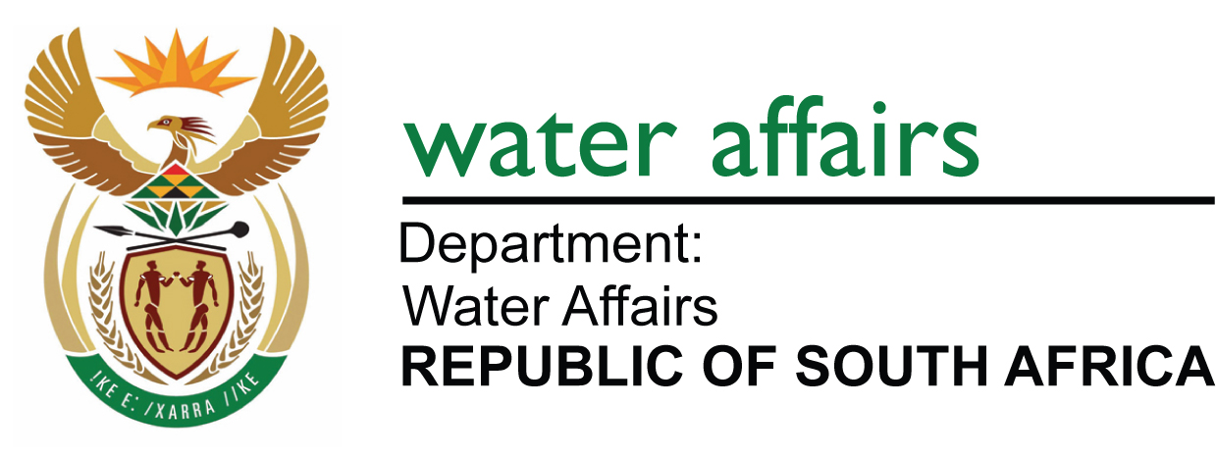
TABLE OF CONTENTS

Page No

1. INTRODUCTION............................................................................................................................. 2
2. PROGRESS WITH IMPLEMENTATION OF THE STRATEGY...................................................... 2
2.1. Strategy Steering Committee ...........................................................................................................2
2.2. Progress with implementation of Water Conservation/Water Demand Management (WC/WDM)................................................................................................................................................ 2
2.3. Progress with Studies ......................................................................................................................4
3. 2010 strategy update............................................................................................................ 6
3.1. Current Water Requirements ...........................................................................................................6
3.2. Intervention Implementation Programme .........................................................................................7
3.3. Adjustments of the Strategy .............................................................................................................7
3.4. Implications Highlighted by the Scenario Planning .........................................................................12
3.5. Implementation of the Ecological Reserve .....................................................................................13
3.6. Impacts of alien vegetation removal on the yield of the WCWSS ..................................................14
4. CONCLUSIONS .............................................................................................................................14
5. RECOMMENDATiONS ..................................................................................................................15

APPENDIX A: EXTENT OF WCWSS
APPENDIX B: REPRESENTATION ON STRATEGY STEERING COMMITTEE
APPENDIX C: IMPLEMENTATION PROGRAMMES
APPENDIX D: ADDITIONAL SCENARIOS CONSIDERED

/tmp/in/input.doc\

- INTRODUCTION

In early 2005, the then Department of Water Affairs and Forestry (DWAF), as the custodian of the country's water resources, in partnership with the City of Cape Town (CCT), commissioned the Western Cape Reconciliation Strategy Study to facilitate the reconciliation of predicted future water requirements with supply available from the Western Cape Water Supply System (WCWSS) for a 25-year planning horizon. The Strategy is used as a decision-support framework for making timeous and informed recommendations on those interventions that should be implemented to meet the future water requirements. The extent of the WCWSS is shown in Appendix A.

The Strategy was completed in 2007 and since then it has been reviewed and updated by the Strategy Steering Committee. A Status Report was produced by the Strategy Steering Committee in September 2009 which gave a brief overview of the 2007 Strategy Document and updates to the Strategy.

This Progress Report provides an overview of the 2010 update to the Strategy.

- PROGRESS WITH IMPLEMENTATION OF THE STRATEGY

  - Strategy Steering Committee

One of the recommendations of the Reconciliation Strategy Study was that a Strategy Steering Committee (SSC) be formed with a clearly defined mandate and scope of work.

The objectives of the SSC are:
• To ensure and monitor implementation of the recommendations of the WC Reconciliation Strategy,
To ensure that the necessary studies by the responsible institutions identified in the Strategy, are started timeously to ensure continued reconciliation of water supply and requirements
• To update the Strategy to ensure that it remains relevant, and
• To ensure that the Strategy, its recommendations and progress with the implementation are appropriately communicated to all stakeholders.

The SSC has met seven times since the Strategy was completed in May 2007. The Committee is functioning as it was intended and the stakeholders and water users of the WCWSS actively partake and provide feedback in the meetings. The list of SSC members is contained in Appendix B.

An Administrative and Technical Support Group (Support Group) was formed to support the SSC. The Support Group consists of inter alia representatives from the Department of Water Affairs’ National Office (Directorates of National Water Resource Planning, Water Resources Planning Systems and Options Analysis), the DWA Western Cape Regional Office and the CCT (Department of Bulk Water Supply and WC/WDM). The Support Group meets between the SSC meetings to ensure that the recommendations of the strategy and committee are implemented.

  - Progress with implementation of WATER CONSERVATION / WATER DEMAND MANAGEMENT (WC/WDM)

The CCT’s comprehensive 10-year WC/WDM Strategy and programme was approved by the Mayoral Committee in May 2007. The WC/WDM Strategy targeted water savings of approximately 90 million m³/a by 2016/2017. In the 2009 Reconciliation Strategy update it was evident that either the growth in actual water requirement was greater than that assumed in the High Water Requirement Curve, or that the CCT’s WC/WDM strategy was not achieving the targeted savings, or that a combination of these two factors was being experienced.

The recommendation which came out of the 2009 Reconciliation Strategy update was that “a monitoring system should be put in place to be able to quantify and measure the success of the WC/WDM interventions which are being implemented”.

Following the September 2009 meeting of the Reconciliation Strategy Steering Committee, the CCT commissioned a professional service provider to conduct a review of the 2007 WC/WDM Strategy to quantify the WC/WDM savings which had been achieved to date and to further comment on whether the proposed savings targets were achievable. The outcome of this review is discussed below.

2.2.1 Progress with Initiatives

The CCT has focussed on a number of WC/WDM interventions over the last three financial years (2007/8 – 2009/10). The following statistics summarise some of the achievements with the implementation of the Strategy and give an indication of the extensive WC/WDM measures which have already been implemented:

- Pressure management was successfully implemented in 13 settlements, including installing pressure reduction devices for 49 schools
- 1 693 Consumer water meters were audited in the Automated Meter-reading Pilot Project (Epping, N2 Gateway and Sunset Beach)
- A total of 1 775 consumers were fitted with automated meter-reading devices
- 20 574 dysfunctional consumer water meters were replaced ,17 998 consumer meters were re-located and fixed and 70 652 water connection leaks were fixed
- 95 users were supplied with treated effluent which accounts for 80.5 Ml/day of re-use
- 341 Caretakers were trained
- 41 Schools were visited and leaks repaired
- 160 Hlonipha Amanzi workshops were held with 14 813 participants
- Water by-laws awareness campaigning at 5 workshops, 12 shopping mall promotions, and with industry and commerce
- More than 50 000 households visited for the integrated leaks repair project.

2.2.2 CCT WC/WDM Budgets and Savings Achieved

The CCT has actively managed the WC/WDM Strategy budget and a number of budget revisions have been necessary throughout the last three years. In the first two years of implementation the CCT actually spent more on WC/WDM than what was required in the WC/WDM strategy. However, in the 2009/10 financial year the CCT budget (and actual expenditure) was much less than the budgeted allocation in the approved Strategy. The approved WC/WDM budget for the 2010/11 financial year is also approximately half that of what is required in terms of the approved Strategy. Figure 1 below shows the original budget, amended budgets, the anticipated savings associated with the budgetary allocations and the actual savings achieved. It must be noted that the actual expenditure figure excludes pipe replacement expenditure and the actual expenditure given is therefore understated.

The review undertaken of the CCT’s WC/WDM Strategy measures implemented conservatively estimated that the CCT had saved approximately 26 million m³/a over the three years from 2007/08 through to 2009/10. This is approximately 70% of the targeted savings contained in the WC/WDM Strategy for the same period. The review concluded that the total targeted savings of approximately 90 million m³/a are still attainable, provided that the WC/WDM strategy is re-aligned and actively supported. Figure 1 below shows the anticipated year-on-year saving contained in the WC/WDM Strategy, as well as the year-on-year actual saving achieved. It must be noted that the actual savings are only shown for those WC/WDM savings which could be measured, and that additional non-quantifiable savings may also have been achieved.

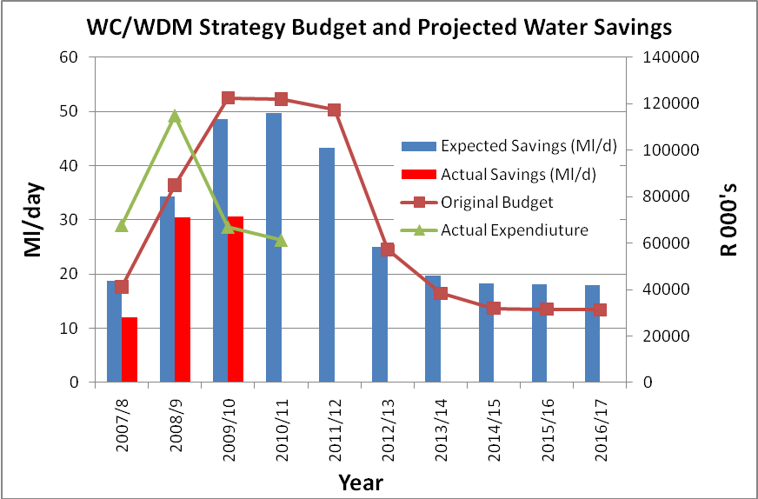
Figure 1: CCT WC/WDM Strategy: Budget, Expenditure and Savings

  - Progress with Studies

This section of the progress report details the progress the DWA and the CCT have made in the implementation of the supply-side interventions.

2.3.1 DWA Studies

The DWA, through the Directorate: Options Analysis undertook a preliminary assessment of six potential surface water development options to augment the Western Cape Water Supply System. Each of these options is based on the diversion of surplus winter water into existing or new bulk storage facilities (dams). The six potential options that have been assessed as part of the Preliminary Assessments are:

- Michell’s Pass Diversion - with storage in the existing Voëlvlei Dam
- Voëlvlei Phase 1 - Berg River abstraction and storage in the existing Voëlvlei Dam
- Voëlvlei Further Phases - Berg River abstraction and storage in Voëlvlei Dam with raising the wall by 2 m
- Molenaars River Diversion - with storage in Berg River Dam or Wemmershoek Dam
- Upper Wit River Diversion - with storage in a new dam near Wellington
- Further Phases of Palmiet River abstraction, with storage in a new raised Lower Steenbras Dam.

In March 2010 a workshop was held in order to determine which of the above-mentioned six options are to be further investigated at feasibility level during the second phase of the project. During this workshop the Upper Wit River Diversion and Molenaars River Diversion were screened out as potential options, mainly due to large environmental impacts and limited available yield.

During the evaluations done for the Breede Overberg Catchment Management Strategy (CMS), which is currently under development by the Breede Overberg Catchment Management Agency (BOCMA), it was determined that there is very limited development potential left in the Breede River if the proposed Environmental Water Requirements are to be adhered to. The Breede Overberg CMS is further recommending that a Water Availability Assessment Study be undertaken for the Breede River catchment before any significant new water allocations are made. The outcome of that assessment could have implications for the development of Michell’s Pass as an augmentation option for the WCWSS.

Based on the outcome of the March 2010 workshop, the DWA has decided to proceed with a full feasibility study for the Voëlvlei Phase 1 as well as for the Michell’s Pass Diversion. The implementation of the latter augmentation option will be subject to water availability in the Breede River Basin.

2.3.2 DWA’s Reconciliation Strategy Studies for All Towns

The All Town Reconciliation Strategies that have been identified as urgent for towns with water resource problems in the Western and Eastern Cape Province have been completed. The strategies for the identified Overberg and Cape Winelands towns will be completed by the end of October 2010 because this input is urgently required for the Breede Overberg CMA’s Catchment Management Strategy which is being developed at the moment. The reconciliation strategies for those towns that are included in the Western Cape Reconciliation Strategy will be completed by November 2010.

On completion of the draft strategies for all the Local Municipalities within a District Municipality (DM), a draft summary report for each DM will be compiled. According to the programme the DM summaries for the Overberg will be available by the end October, and for Winelands and the West Coast by end November 2010. A very short Provincial Overview Report that summarises the most important findings will be compiled early in 2011.

2.3.3 CCT Studies

The exploratory phase of the CCT’s Feasibility Study and Pilot Project into the potential for developing the TMG groundwater aquifer will be completed by the end of November 2010. A decision of whether or not to proceed with the pilot phase of the project will be made by the Mayoral Committee of the CCT in early 2011. Subject to the successful completion of the CCT’s feasibility study, it is anticipated that the earliest implementation date of a full-scale production well-field would be in 2020.

The remaining feasibility studies identified as the responsibility of the CCT have yet to commence. It is the intention of the CCT to appoint a professional service provider to commence with feasibility studies for desalination of seawater by the end of January 2011 and for large scale re-use of water by the end of February 2011.

Due to human resource capacity and budget constraints, feasibility studies on the development of the Laurens River, Cape Flats Aquifer and Newlands Aquifer will only commence in the CCT’s 2011/12 financial year.

2.3.4 Other Municipalities

Stellenbosch Municipality reported that human resource capacity constraints had been impacting on their ability to undertake effective WC/WDM, but that some of the most serious problems identified earlier had been addressed. Approximately R89 million has been made available for infrastructure maintenance on Waste Water Treatment Works. The municipality does not have sufficient reservoir capacity as they do not conform to the 48-hours spare capacity requirement. The response time to breaks and bursts is therefore critical at the moment. On the strategy side, there has been limited progress over the last year. The WASP (draft 2007) will be finalised early in 2011 so that the municipality can plan for implementing future WC/WDM measures. However, even though no WC/WDM strategy is in place, leak repairs are currently being done in order to minimise large water losses from the system.

- 2010 strategy update

  - Current Water Requirements

For the purposes of reconciling water supply and requirement in the WCWSS, the water requirements for the period 2009/10 were compared with the available supply. Estimates of water requirements were made for those months where actual water requirement information was not yet available. The actual sectoral water use pattern in the WCWSS for 2010 was as follows:

Urban: 345 million m³/a (74% of the total)
Irrigation estimated: 119 million m³/a (26% of the total)
TOTAL 464 million m³/a

For planning purposes the actual water requirement for agriculture was “adjusted” to take into account the variability of rainfall and the fact the agricultural sector can still grow into their capped allocation. It is important to use the “adjusted” total water requirement for planning purposes as it is in times of drought when the agricultural sector will maximise their water use from the WCWSS, as their farm dams may not be full. The “adjusted” total water use from the WCWSS is given below and also shown in Figure 2.

Urban: 345 million m³/a (68% of the total)
Irrigation estimated: 166 million m³/a (32% of the total)
TOTAL 511 million m³/a

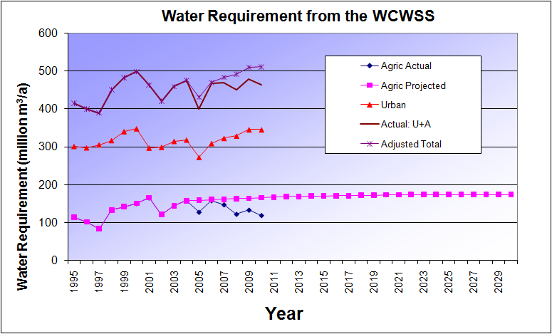

Figure 2: Water Requirements from the WCWSS

A comparison between the adjusted total water requirement from the WCWSS and the high water requirement curves developed during the Reconciliation Strategy Study (refer to Figure 3) shows that the adjusted total water requirement falls just below the high water requirement curve

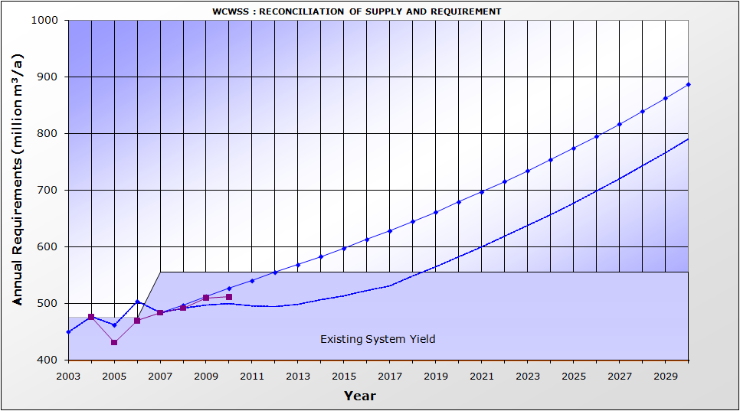
High Water Requirement Curve
Actual Water Requirement Curve
High Water Requirement Curve with WC/WDM
Figure 3: Total and Projected water requirement from the WCWSS

The adjusted total water usage from the WCWSS for 2010 came to approximately 511 million m³/a, compared to the existing WCWSS available yield of 556 million m³/a.

  - Intervention Implementation Programme

The updated implementation programmes for the Voëlvlei Phase 1 Augmentation Scheme, the water re-use scheme, and the TMG scheme is shown in Appendix C of this Report. An implementation programme for the desalination of seawater can be assumed to be similar to the programme developed for a water re-use scheme. A comparative fast-tracked programme for these schemes is also shown in Appendix C. Fast-tracking an intervention could be achieved through either minimising the time taken by the approval processes, and/or running the environmental approval process and scheme design as a parallel process.

The construction programme for any of these interventions would be quite tight and is based on a number of construction activities being implemented in parallel.

  - Adjustments of the Strategy

In order to obtain a good understanding of the range of possible implementation dates of the next required supply-side intervention, three scenarios were developed taking account of updated water requirements, the potential effectiveness of implementing WC/WDM measures and achieving the targeted savings, potential climate change impacts, the current status quo of the feasibility studies, and implementation progress.

The following three scenarios were investigated:

- Scenario 1: 2010 Reference Scenario: “High water requirement”, CCT WC/WDM strategy 100% successful (2011 to 2017), no climate change
- Scenario 2: WC/WDM 50% successful: “High water requirement”, CCT WC/WDM strategy 50% successful (2011 to 2017), no climate change
- Scenario3: “Worst-Case” Scenario: “High water requirement”, CCT WC/WDM strategy 50% successful (2011 to 2017) with possible effects of climate change.

More scenarios exist between the 2010 Reference Scenario and the “Worst-Case” Scenario, but if solutions could be found for these two scenarios, all others should be covered. Should the adjusted total water requirement follow a lower trajectory than the High Water Requirement Curve, then the required implementation date of interventions could be delayed and more options for implementation would become available to select from.

Two sub-scenarios to Scenario 2 were considered to ascertain what the impact on the water balance (and the implementation date of the next supply-side intervention) would be under the following circumstances:
- Scenario 2 (a): Verification and validation of agricultural water use, and
- Scenario 2 (b): 3.5% year-on-year water requirement growth rate for the West Coast t-Towns as opposed to a 6% per annum growth rate.

The outcome of the two sub scenarios is documented in Appendix D.

3.3.1 Scenario 1: 2010 Reference Scenario (“High water requirement”, WC/WDM 100% successful, no climate change effects)

The 2010 Reference Scenario assumes that the CCT is able to achieve its remaining year-on-year WC/WDM targets for the period 2011 to 2017, based on its WC/WDM Strategy and programme. The WC/WDM savings reported for the first three years (from 2007 to 2010) have been adopted as actual savings achieved. Under this scenario the requirement for water would exceed the available supply in 2019 (see Figure 5).

A comparison between the adjusted total water requirement from the WCWSS and the available supply is shown in Figure 4 above.

The following interventions would be available for implementation by 2019:
- Voëlvlei Phase 1
- Water re-use
- Desalination of seawater.

The following interventions will not be available for implementation by 2019:
- Michell’s Pass Diversion – potentially subject to a Water Availability Assessment Study in the Breede River to determine the available yield
- Raising of Steenbras Upper Dam – longer lead time required to implement
- TMG Aquifer – the TMG Aquifer has been identified as a potentially significant source of water for future supply to the WCWSS. It is however envisaged that any large-scale development of the TMG Aquifer will only occur upon completion of the CCT’s current initiative, once the feasibility and sustainability of large-scale abstraction for the WCWSS has been established. Earliest implementation date currently estimated as 2020
- Development of the Lourens River Diversion, Cape Flats or Newlands Aquifer – not available for implementation by 2019 as the CCT, with its current limited human and financial resources, has decided to focus its attention on initiating water re-use and desalination feasibility studies as their first priority.

After the implementation of one of the three options by 2019, a whole range of options then become available to be implemented over time. A possible reconciliation of supply and requirement based on lowest Unit Reference Value (URV) is shown in Figure 4 below, taking into account those interventions that could potentially be implemented in time. This represents only one potential development sequence. Other potential development sequences could include seawater desalination.
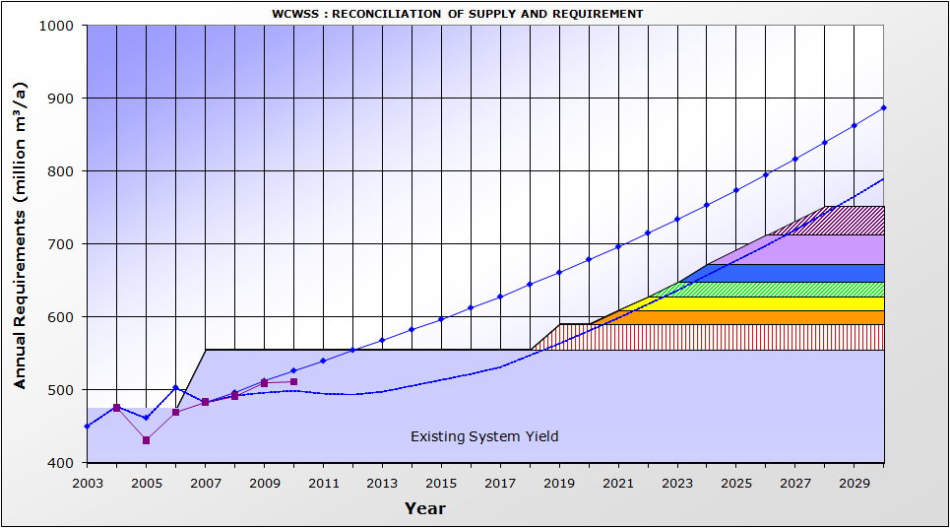
4
5
6
7
3
2
1
High Water Requirement Curve
Actual Water Requirement Curve
High Water Requirement Curve with WC/WDM
Figure 4: Reconciliation of Water Supply and Requirement for the 2010 Reference Scenario based on lowest URV

In Table 1 (below) the interventions which have been used in Figure 4 are listed.
Intervention required by 2019

Table 1: 2010 Reference Scenario: Supply-side interventions that could be implemented

No | Intervention | Year of First  Water | Yield  (million m³/a) | Fast-  tracked  9  10  8  7  1  6  2  4
1 | Voëlvlei Phase 1 | 2019 | 35 | No
2 | Lourens River development | 2021 | 19 | No
3 | Cape Flats Aquifer | 2022 | 18 | No
4 | TMG Scheme 1 | 2023 | 20 | No
5 | Raise Lower Steenbras Dam | 2024 | 25 | No
6 | Water Re-use Scheme Generic 1 | 2025 | 40 | No
7 | Water Re-use Scheme Generic 2 | 2027 | 40 | No

It is important to note that the implementation dates almost follow year-on-year, due to the relative small yields of the different schemes.

3.3.2 Scenario 2: WC/WDM 50% successful (“High water requirement”, WC/WDM 50% successful, with no climate change effects)

This Scenario assumes that the CCT is only able to achieve 50% of its remaining year-on-year WC/WDM targets for the period 2011 to 2017, based on its WC/WDM strategy and programme. Under this scenario the requirement for water would exceed the available supply in 2017. Only fast-tracking of an intervention could enable the reconciliation of supply and requirement by 2017.

DWA and CCT would have to take a decision by March 2012 on whether or not to fast-track the implementation of an intervention in order to enable the finally chosen intervention to be designed, implemented and able to deliver first water by 2017.

A possible reconciliation of supply and requirement for the WC/WDM 50% successful Scenario is shown in Figure 5. This represents only one potential development sequence.

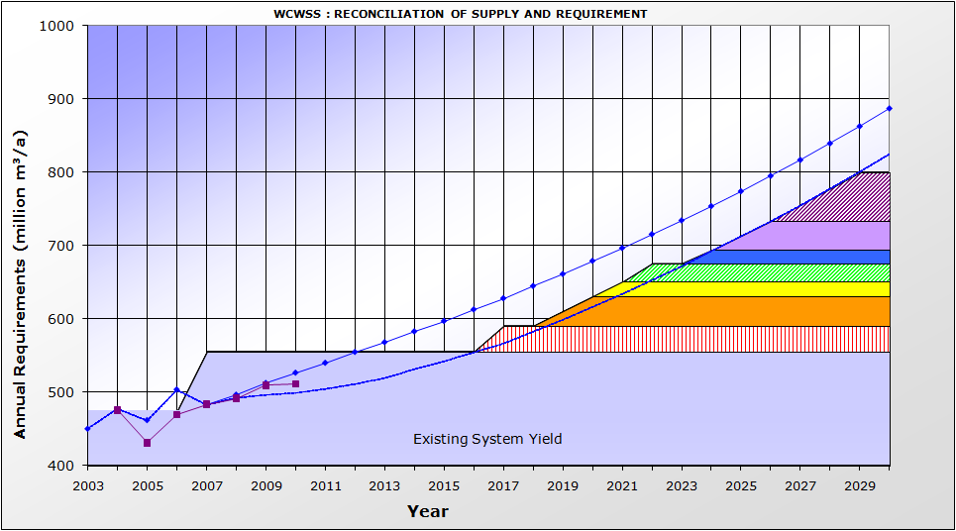
4
5
6
7
3
2
1
High Water Requirement Curve
Actual Water Requirement Curve
High Water Requirement Curve with WC/WDM

Figure 5: Reconciliation of Water Supply and Requirement under a 50% successful WC/WDM scenario

Table 2 lists the supply-side interventions which have to be implemented in order to ensure the reconciliation of supply and requirement up to 2030 under this scenario.

Table 2: 50% Success with WC/WDM: Supply-side interventions implemented
No | Intervention | Year of First  Water | Yield  (million  m³/a) | Fast-  tracked
1 | Voëlvlei Phase 1 | 2017 | 35 | Yes
2 | Water Re-use Scheme Generic 1 | 2019 | 40 | No
3 | TMG Scheme 1 | 2021 | 20 | No
4 | Raise Lower Steenbras Dam | 2022 | 25 | No
5 | Cape Flats Aquifer | 2024 | 18 | No
6 | Water Re-use Scheme Generic 2 | 2025 | 40 | No
7 | Seawater Desalination Scheme | 2027 | 66 | No

3.3.3 Scenario 3: “Worst-Case Scenario” (“High water requirement”, WC/WDM 50% successful, with potential climate change effect)

The Worst-Case Scenario assumes that the CCT is only able to achieve 50% of the remaining total WC/WDM target proposed in the 10-year WC/WDM Strategy and Programme. This scenario also assumes that climate change will impact on the available yield of the WCWSS. Under this scenario the requirement for water would exceed the available supply in 2016 and potential water shortages may occur. No interventions would be available to deliver first water by 2016. Fast-tracking of some of the interventions could, however, enable the reconciliation of supply and requirement by 2017. Under this scenario

Under the Worst-Case Scenario, the DWA and CCT would have to take a decision by March 2012 on which interventions to fast- track in order to enable the finally chosen intervention to be designed, implemented and able to deliver first water by 2017.

The assumption used for the potential effect of climate change in the 2007 Reconciliation Strategy Study was that the available yield of existing and future surface water interventions would negatively decrease by 15% over the next 25 years, and that the yield of groundwater resources would decrease by 5% over the next 25 years. This would result in a reduction in yield of approximately 3 million m³/a for each year over the next 25 years, (a total of approximately 75 million m³). During the SSC meeting held in March 2009, Professor Bruce Hewitson of the Climatology Department of the University of Cape Town confirmed that the scenario planning assumptions adopted for the surface water interventions could be regarded as a realistic possible future scenario. According to Professor Hewitson, the global climate change models predict that there could be a mean long-term trend for drying in the Western Cape (with less certainty in the mountains). It is further anticipated that more frequent intense rainfall events may occur. Whilst there is a general acceptance that climate change is occurring, the long-term rainfall records at Wemmershoek and Steenbras dams do currently not yet show any evidence of significant short-term or long-term variance in annual rainfall patterns.

It would be very costly to implement additional interventions to offset the potential decrease in yield as a result of climate change. Interventions should therefore only be implemented if proof of a long-term decrease in rainfall were to be found. It is, however, imperative that a strategy be developed, and that all the preparatory planning studies be undertaken now so that it would be possible for the responsible authorities to respond to climate change should it become a reality. In this regard it is important to monitor for any trend changes in rainfall and run off and to understand the possible impacts of climate change on water requirements. A possible reconciliation of supply and requirement for the Worst-Case Scenario is shown in Figure 6. This represents only one potential development sequence.

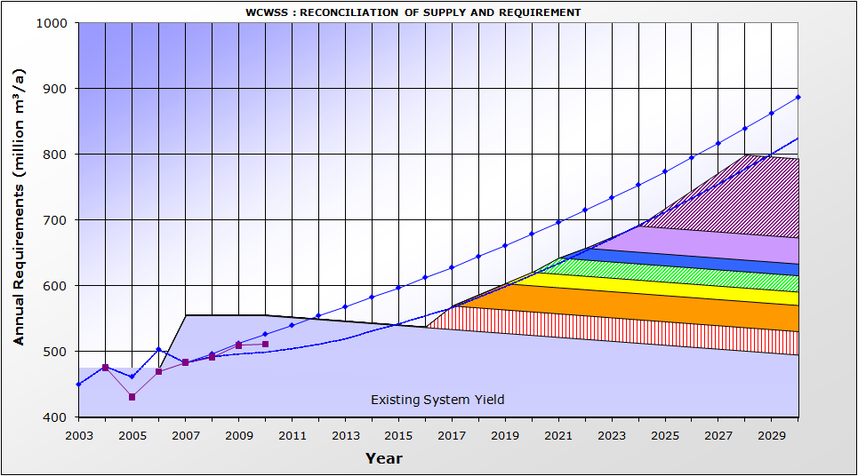
4
5
6
7
3
2
1
High Water Requirement Curve
Actual Water Requirement Curve
High Water Requirement Curve with WC/WDM
Figure 6: Reconciliation of Water Supply and Requirement for the Worst-Case Scenario to offset the potential impacts of Climate Change

Table 3 lists the supply-side interventions which have to be implemented in order to ensure the reconciliation of water supply and requirement up to 2030 for the Worst-Case Scenario.

Table 3: “Worst Case” Scenario: Supply-side interventions to be implemented
No | Intervention | Year of First  Water or Saving | Yield  million  m³/a | Fast-  tracked
1 | Voëlvlei Phase 1 | 2017 | 35 | Yes
2 | Water Re-use Scheme Generic 1 | 2018 | 40 | Yes
3 | TMG Scheme 1 | 2021 | 20 | No
4 | Raise Lower Steenbras Dam | 2022 | 25 | No
5 | Cape Flats Aquifer | 2022 | 18 | No
6 | Water Re-use Scheme Generic 2 | 2023 | 40 | No
7 | Seawater Desalination | 2025 | 66 | No

  - Implications Highlighted by the Scenario Planning

In the 2010 Reference Scenario the only surface water intervention which could be implemented by 2019 is the Voëlvlei Phase 1 Augmentation Scheme. In order to enable the DWA and the CCT to have a wider selection of interventions to choose from, it is imperative that the CCT commence with its feasibility studies of water re-use and desalination by the end of 2010 / early 2011. Large-scale desalination is still expected to be more expensive than a water re-use scheme. Large-scale desalination should, however, also be investigated as it may be socially more acceptable than water re-use. It also represents the ultimate long-term solution for water supply to the WCWSS. The cost of large-scale desalination would also be used as a benchmark for the cost of any water supply schemes. It is therefore recommended that the CCT investigate the feasibility of large-scale seawater desalination in parallel to investigating the feasibility of water re-use.

The CCT has achieved approximately 70% of the targeted WC/WDM savings for the period 2007/08 to 2009/10. Should the identified savings for the remainder of the strategy period be achieved, a new supply-side intervention would only be required by 2019. However, should the CCT only achieve 50% of their year-on-year targeted savings for the remainder of the strategy period, then a new intervention would be required by 2017. It must be noted that 2017 is the earliest realistic date that can be achieved through the fast-tracking of a supply-side intervention. Should WC/WDM be less successful or should the growth in water requirement exceed the growth rates upon which the High Water Requirement curve was based, a new intervention could be required earlier than 2017. Two possible options exist to reconcile supply and requirement before 2017, namely:
- Implement an emergency scheme e.g. seawater desalination
- Impose low-level water restrictions.

Should an emergency scheme be implemented (as a result of climate change effects, a drought, less than successful WC/WDM) desalination may be a more socially-acceptable intervention to fast-track than water re-use. Desalination, however adds additional water treatment plant capacity to the WCWSS, which may not be required should the proposed Muldersvlei water treatment plant be implemented. The implications of these aspects will be addressed by the desalination feasibility study which the CCT is planning to undertake.

By studying the above-mentioned interventions in parallel to feasibility level, and by undertaking the Environmental Impact Assessments simultaneously, the DWA and the CCT would be proactive in their planning and would be able to make the most appropriate choice of which intervention to implement as the next water augmentation scheme.

  - Implementation of the Ecological Reserve

The ecological Reserve requirement of the Berg River downstream of the Berg River Dam was built into the design and operational rules for the scheme and is currently being released. However, dams constructed prior to the Berg River Dam are not yet releasing the ecological Reserve requirements. Based on the 2010 Reference Scenario, it is proposed that the ecological Reserve on “old dams” should only be phased in after 2019. Should the Reserve be implemented prior to 2019, it would not be possible to implement interventions to offset the loss in yield due to the required environmental flow releases. The implementation of the Reserve should be phased in, in a planned manner, based on the implementation dates of future water augmentation schemes. Figure 7 illustrates a possible scenario for the implementation of the Reserve after 2019.
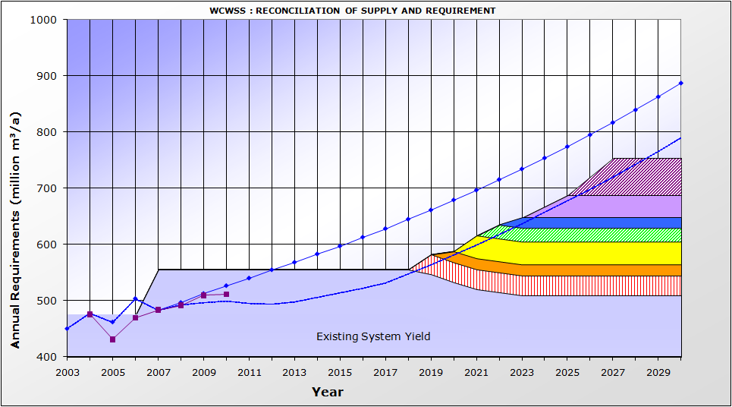
4
5
6
7
3
2
1
High Water Requirement Curve
Actual Water Requirement Curve
High Water Requirement Curve with WC/WDM

Figure 7: Reconciliation of water supply and requirements with phasing in of the ecological Reserve on “old” dams

Table 4 lists the supply-side interventions which have to be implemented in order to ensure the reconciliation of supply and requirement up to 2035 should the ecological Reserve be implemented.

Table 4: Ecological Reserve implementation Scenario: Supply-side interventions implemented
No | Intervention | Year of First  Water or Saving | Yield  million  m³/a | Fast-  tracked
1 | Voëlvlei Phase 1 | 2019 | 35 | No
2 | TMG Scheme 1 | 2020 | 20 | No
3 | Water Re-use Scheme Generic 1 | 2021 | 40 | No
4 | Raise Lower Steenbras Dam | 2022 | 25 | No
5 | Cape Flats Aquifer | 2023 | 18 | No
6 | Water Re-use Scheme Generic 2 | 2024 | 40 | No
7 | Seawater Desalination | 2026 | 66 | No

  - ImpACTS of INVASIVE alien plants removal on the yield of the WCWSS

The removal of invasive alien plants is regarded as an important intervention to increase water availability. Studies undertaken for DWA have previously indicated that the effective clearing of invasive alien plants results in increased yields of existing and future water resource development options.

As part of the 2010 Reconciliation Strategy update an analysis was undertaken to determine what the impacts would be of clearing invasive alien plants upstream of the major dams supplying the WCWSS. A comparative assessment was also undertaken using invasive alien plant mapping from two different sources, namely the Western Cape Water Availability Assessment Study (WAAS) and the National Invasive Alien Plant Survey (NAIPS) commissioned by Working for Water (WfW). The results are presented in Table 5 below.

Table 5: Invasive Alien Plant Clearance: Various scenarios

Scenario | Percentage IAP infestation of untransformed land with slope <45 degrees | Total area of IAP infestation (km²) | Streamflow reduction (million m³/a) | Yield reduction (million m³/a)
WAAS | Approx. 1% | 7.92 | 4.09 | 0
NAIPS | Approx. 25% | 218 | 35.3 | -18

Using the WAAS mapping it would appear that the current infestation levels do not reduce the yield of the WCWSS. Using the NAIPS mapping the current alien plant infestation levels result in a decrease in yield of 18 million m³/annum. There is quite a big discrepancy in the results, dependent on which mapping is used. The NAIPS mapping was a national study undertaken at quaternary catchment level and the WAAS mapping was undertaken at a much finer resolution. This could explain the difference in infestation areas which were calculated. It is therefore important to verify the actual infestation areas.

Working for Water has initiated a study entitled “Improving Understanding of the Rate of Spread and Impacts of Invasive Alien Plants”. Once this study has been completed it would be important to update the assumptions used for the modelling of invasive alien plants within the WCWSS.

- CONCLUSIONS

The following conclusions can be drawn from the 2010 scenario planning and strategy update:

- The successful implementation of WC/WDM remains absolutely critical and is very important to ensure the ongoing reconciliation of supply and requirement.
- A number of supply schemes (Upper Wit River Diversion and Molenaars River Diversion) which were originally identified as potential supply-side interventions, are currently, based on the outcome of the pre-feasibility study, not deemed feasible. In addition to this the implementation of Michell’s Pass Diversion is likely to be subject to a Water Availability Assessment Study in the Breede River. This places more importance on determining the feasibility of the remaining interventions, especially the raising of Steenbras Lower Dam and Water Re-use.
- It may become necessary to fast-track supply-side interventions in order to implement the interventions by 2017 (earliest possible date). Fast-tracking would be required if the WC/WDM targets set in the CCT’s WC/WDM strategy are not attained or if climate change starts impacting on water availability within the WCWSS. A recommendation on fast-tracking would need to be made by the Strategy Steering Committee in March 2012.
- The choice of which intervention to implement will be dependent on the growth in water requirement. If the growth in water requirement is lower than the high water requirement curve, then it may be possible to implement the intervention with the lowest URV, namely development of the Lourens River Dam. However, if the water requirements keep on growing at the current rate, it is important to continue with feasibility studies for other interventions as well.
- It is important to update and understand future water requirements. Based on the CCT’s review of their WC/WDM Strategy, it would appear that the unconstrained growth in water requirement for the City of Cape Town has averaged 3.5% per annum over the last three years. This is in comparison to a growth rate for the CCT of 3.1%/a – which forms the basis of the High Water Requirement Curve developed for the Reconciliation Strategy.
- It is important to implement a system to monitor potential indicators for climate change and to monitor the CCT’s success in implementing their WC/WDM Strategy measures.
- There is uncertainty surrounding the actual extent of invasive alien plant infestation areas in the catchment areas of the dams in the WCWSS.

- RECOMMENDATiONS

The following recommendations follow from the assessment of the current water requirements and updated scenario planning:

- The CCT must actively continue with the implementation of their 10-year WC/WDM Strategy.
- Regular reviews of the WC/WDM Strategy should be undertaken in order to ensure the objectives and targets set by the strategy are achieved.
- The Feasibility Studies as identified in the 2007 Reconciliation Strategy Study and the 2009 Scenario Planning update need to continue or start, namely:
  - Surface water options by DWA – continue
  - Table Mountain Group Aquifer (TMG) study by CCT – continue
  - Newlands Aquifer, Cape Flats Aquifer and Lourens River studies by CCT – start in next CCT financial year
  - Water Re-use – CCT to urgently implement a feasibility Study
  - Desalination of seawater – CCT to urgently implement a feasibility Study
- A monitoring system must be put in place to serve as an early warning system should climate change start impacting on water availability and/or water requirements.
- The assumptions made in the 2007 Strategy in terms of population growth projections, economic growth projections and anticipated service delivery programmes should be reviewed and updated in order to ascertain if the assumptions surrounding the development of the 2007 High Water Requirement Curve are still valid.
- Upon completion of the WfW study entitled “Improving Understanding of the Rate of Spread and Impacts of Invasive Alien Plants”, the assumptions used for the modelling of invasive alien plants within the WCWSS should be revisited.
- The Reconciliation Strategy for the Western Cape Water Supply System should be re-assessed in September 2011 and adjusted if required.
REFERENCES

DWAF, 2007. Western Cape Reconciliation Strategy Study.

DWA, 2009. Western Cape Water Supply System, Reconciliation Strategy, Status Quo Report, December 2009.

City of Cape Town, 2010. Progress with Implementation of the Long Term Water Conservation and Water Demand Management Strategy, Assessment, Summary Report, September 2010.

Appendix A

EXTENT OF WCWSS

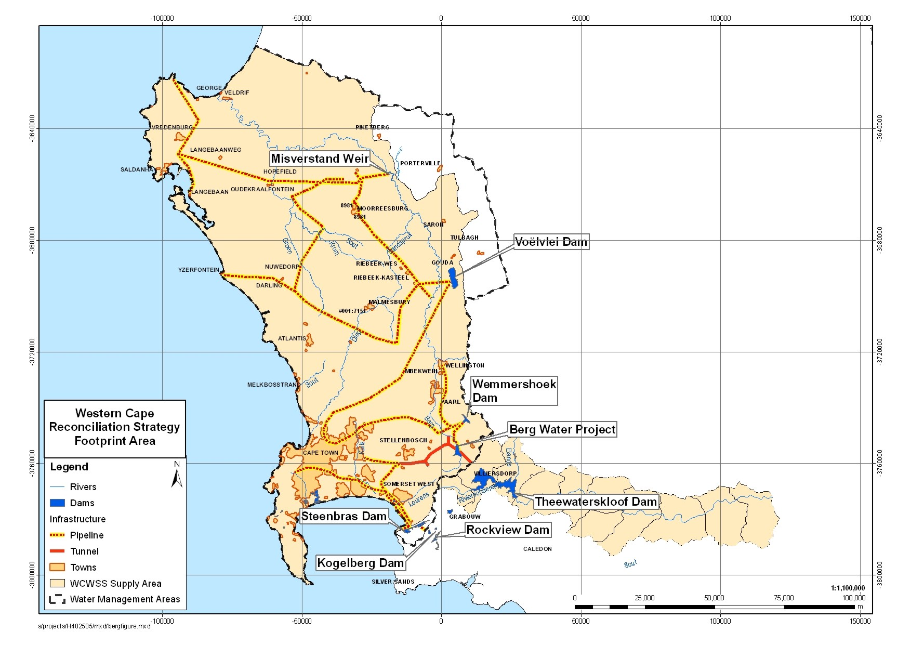

Appendix B

REPRESENTATION ON STRATEGY STEERING COMMITTEE

WESTERN CAPE STRATEGY STEERING COMMITTEE REPRESENTATION

ORGANISATION | ADDRESS
National Government
Department of Water Affairs (Head Office) | Private Bag X313, Pretoria 0001
Department of Water Affairs (Regional Office) | Private Bag X16, Sanlamhof 7532
Western Cape Provincial Government
Department of Agriculture | P/Bag X1 Elsenburg 7607
Department of Local Government and Housing | P/Bag X9083 Cape Town 8000
CapeNature | P/Bag X29 Rondebosch 7701
Dept of Environmental Affairs and Development Planning | P/Bag X9086, Cape Town 8000
- Planning Branch
- Environmental Branch
Local Authorities
City of Cape Town | PO Box 16548 Vlaeberg
- Bulk Water
- Waste Water
- WC/WDM
West Coast DM | PO Box 242, Moorreesburg 7310
Cape Winelands DM | PO Box 91, Worcester 6849
Drakenstein LM | PO Box 1, Paarl, 7620
Stellenbosch LM | PO Box 17, Stellenbosch
Witzenberg Municipality
CMAs
Berg | Not yet established
Breede-Overberg | Private Bag X3055 Worcester 6850
WUAs
Berg WUA | PO Box 540, Wellington 7655
Breede and Overberg WUAs | PO Box 232, Robertson 6705

Appendix C

INTERVENTION IMPLEMENTATION PROGRAMME

Voëlvlei Diversion
Pre-feasibility
Feasibility (years)
Feasibility Study/ EIA
DWAF Reserve determination
Construction/Implementation (years)
Lag time (approvals and budget delay)
TOR / Appoint Consultant
DWAF licensing process (Reserve)
DEA&DP approval process
Design
tender prepar. & award
Construct
Pre-feasibility
Feasibility (years)
Feasibility Study/ EIA
DWAF Reserve determination
Construction/Implementation (years)
Lag time (approvals and budget delay)
TOR / Appoint Consultant
DWAF licensing process (Reserve)
DEA&DP approval process
Design
tender prepar. & award
Construct
1
2
3
4
9
10
11
12
5
6
7
8
13
YEARS - NORMAL PROGRAMME
YEARS - FAST-TRACKED
1
2
3
4
5
6
7
2009
2010
2011
2012
2019
2020
8
9
10
11
2017
12
13
2014
2015
2016
2021
2021
2009
2010
2011
2012
2013
2017
2018
2018
2019
2020
2013
2014
2015
2016

Appendix D

ADDITIONAL SCENARIOS CONSIDERED

WC/WDM 50% successful and verification, validation and licensing of agricultural water use

This Scenario assumes that the CCT is only able to achieve 50% of the total saving identified in its approved 10-year WC/WDM Strategy and Programme. The scenario further assumes that verification, validation and licensing of agricultural water use will take place by 2014. The agricultural water users from the WCWSS currently have the same level of assurance of supply as the urban sector (98%) until agricultural water use reaches its capped allocation. Under this scenario agricultural water requirements would decrease from 174 million m³/a (capped allocation at a 98% level of supply assurance) to approximately 174 million m³/a at a 91% level of supply assurance. This equates to a 156 million m³/a at a 98% level of assurance of supply.

Under this scenario the requirement for water would exceed the available supply in 2018 and interventions would need to be fast-tracked in order to ensure implementation by this date. By undertaking verification, validation and licensing of agricultural water use, the implementation date of the next supply-side intervention could be delayed by one year.

A possible reconciliation of supply and requirement for this scenario is shown in the Figure and Table below. This represents only one potential development sequence.

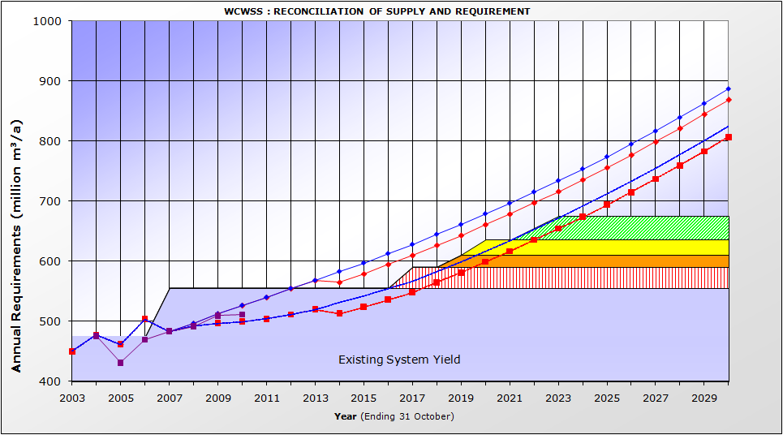
High Water Requirement Curve
High Water Requirement Curve with licensing
Intervention required by 2018
Delays implementation on next supply intervention by 1 year

Reconciliation of Water Supply and Requirement with the verification, validation and licensing of agricultural water use

INTERVENTION SELECTION |  | YEAR | YIELD
1 | Voëlvlei Phase 1 | 2017 | 35
2 | TMG Scheme 1 | 2019 | 20
3 | Raise Lower Steenbras | 2020 | 25
4 | Re-use Generic 1 | 2022 | 40

WC/WDM 50% successful and reduced growth in West Coast water requirements (from 6% pa to 3.5% pa)

This scenario assumes that the CCT is only able to achieve 50% of the total saving identified in its approved 10-year WC/WDM Strategy and Programme. The scenario further assumes a 3.5% per annum growth in water requirement for the towns making up the supply to the West Coast and not a 6% per annum growth in water requirement as was originally assumed in the 2007 Strategy and 2009 Strategy update. Under this scenario the requirement for water would exceed the available supply in 2018 and interventions would need to be fast-tracked in order to ensure implementation by this date. If a 3.5% growth rate is assumed for the West Coast Towns, the implementation date of the next supply-side intervention would be delayed by one year.

A possible reconciliation of supply and requirement for this scenario is shown in the Figure and Table below. This represents only one potential development sequence.

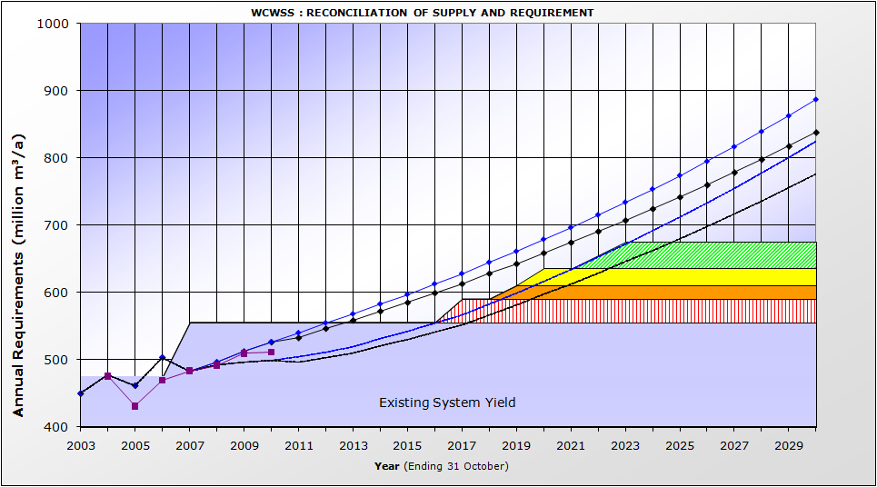
High Water Requirement Curve
High Water Requirement Curve with 3.5% growth rate for WC Towns
Intervention required by 2018
Delays implementation on next supply intervention by 1 year

Reconciliation of Water Supply and Requirement for a 3.5% water requirement growth rate for the West Coast Towns

INTERVENTION SELECTION |  | YEAR | YIELD
1 | Voëlvlei Phase 1 | 2017 | 35
2 | TMG Scheme 1 | 2019 | 20
3 | Raise Lower Steenbras | 2020 | 25
4 | Re-use Generic 1 | 2022 | 40

